Resource group creation.

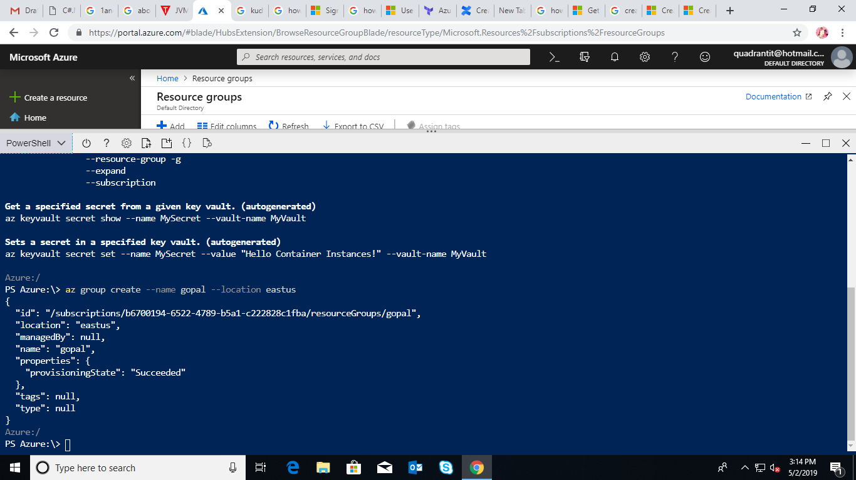

Vnet creation.

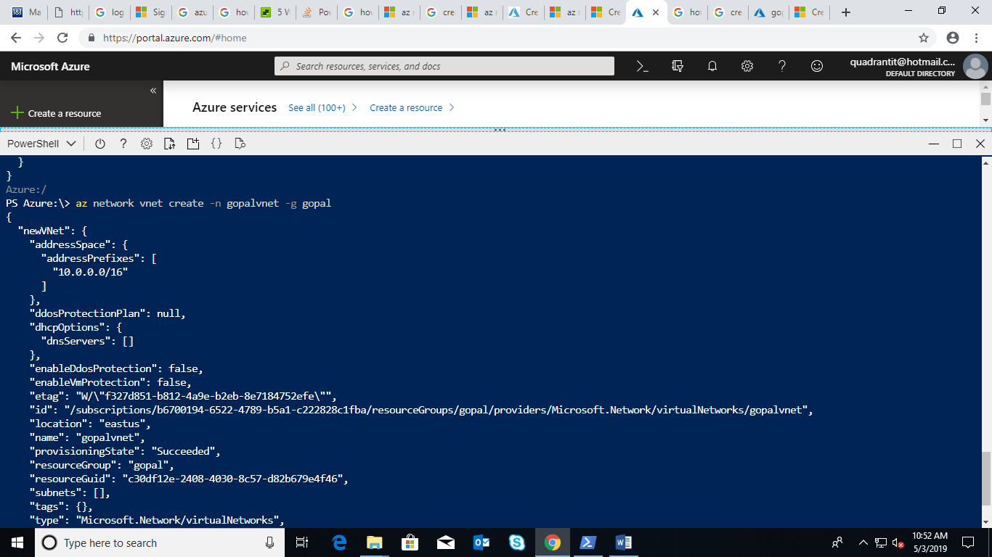

Creation of Subnets for vnet1.

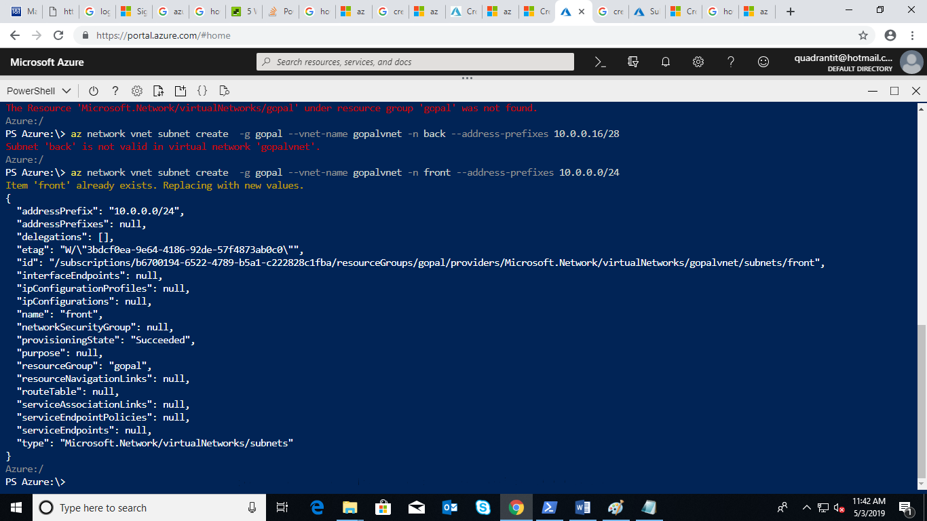

Creation of subnet gateway ,Frontend subnet and Backend subnet for vnet1.

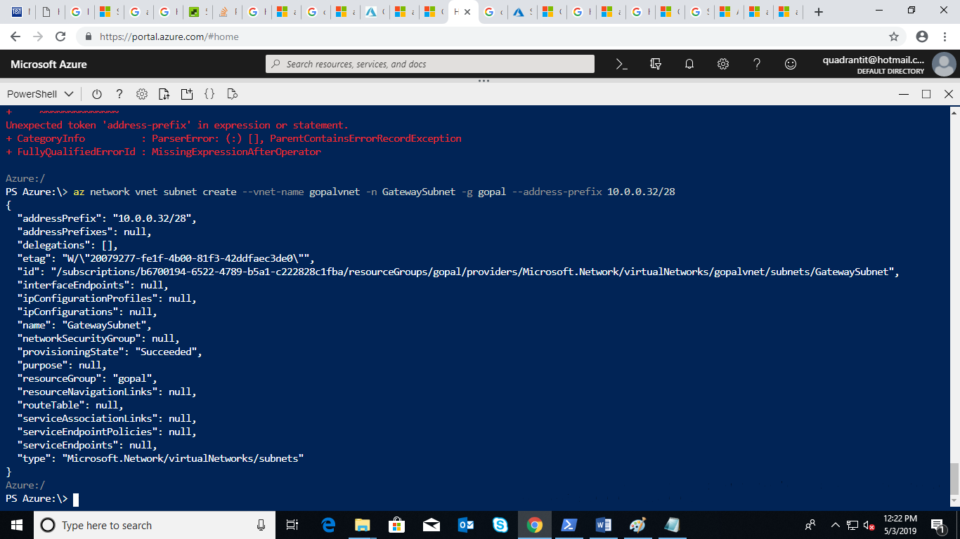

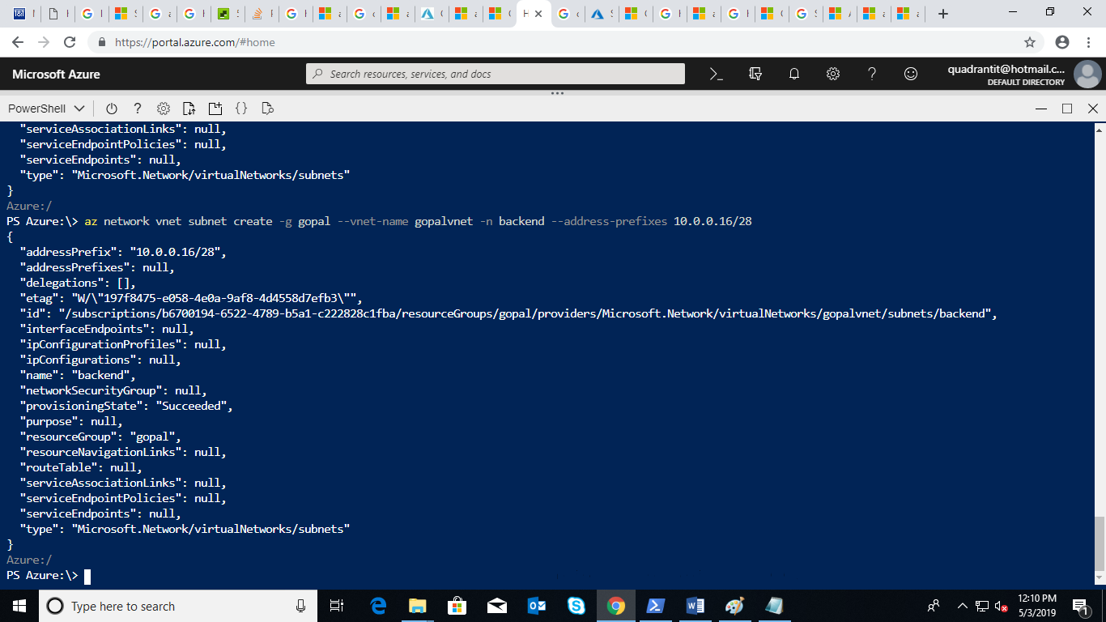

Creation of Vnet2.

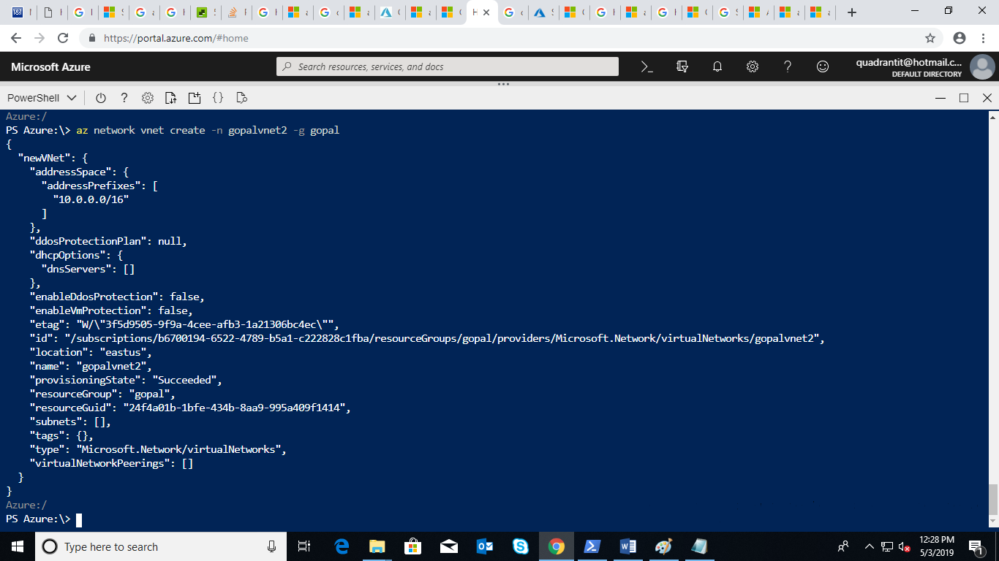

Creation of subnets and subnet gateway for vnet2.

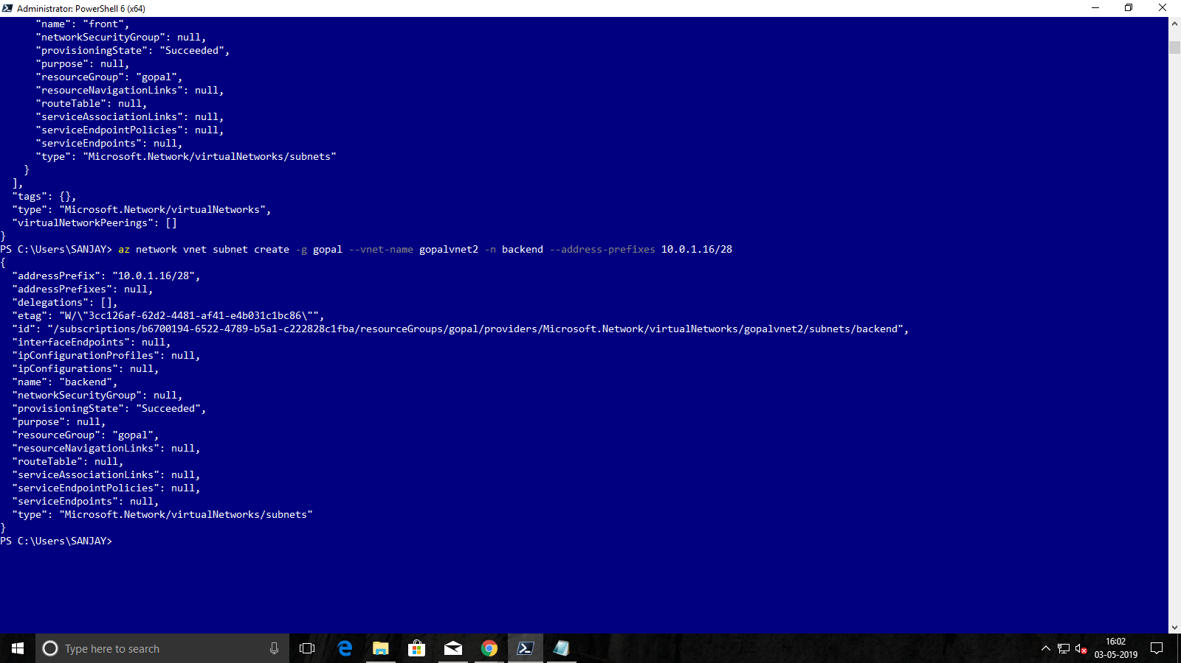

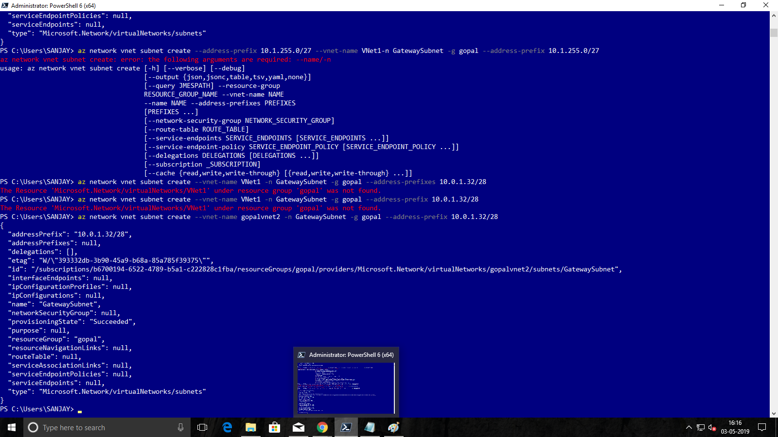

Vnet3 Creation.

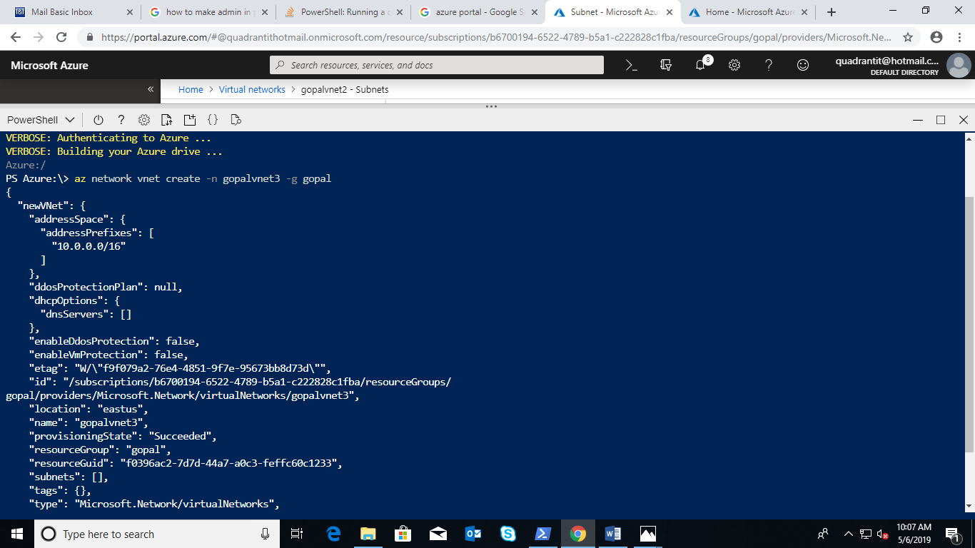

Creation of front ,Backend subnets and subnet Gateway for vnet3.

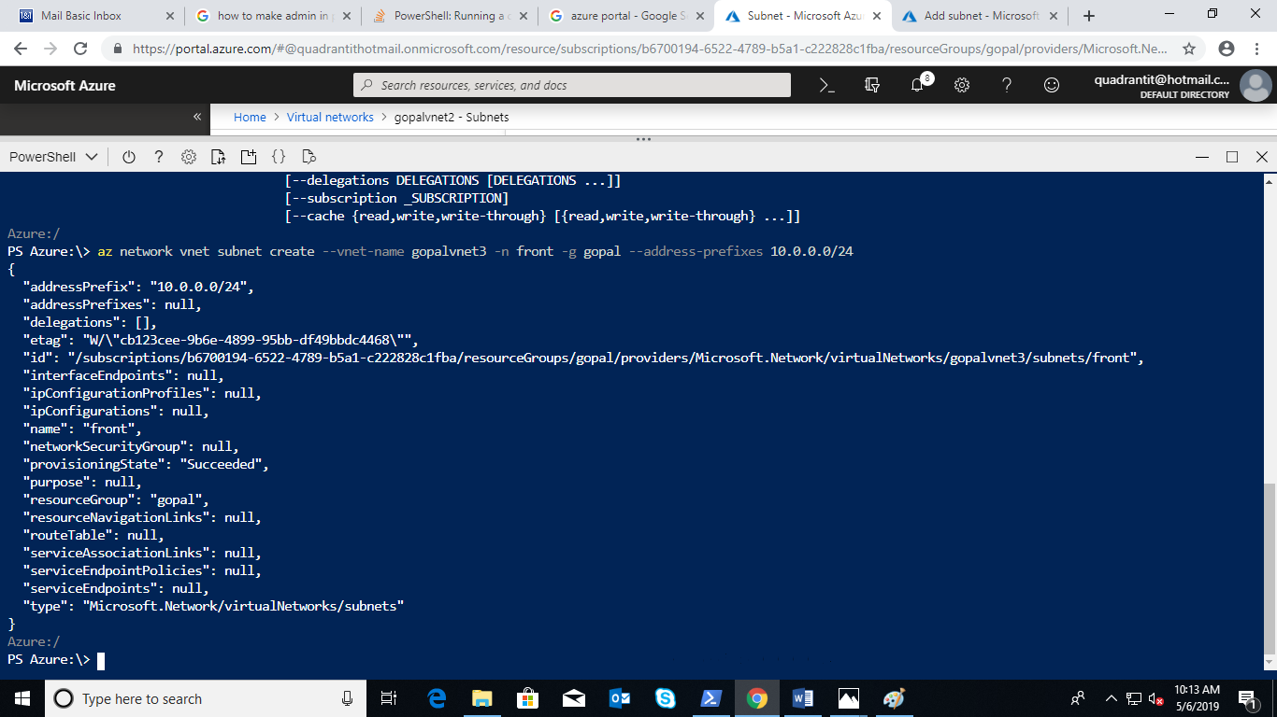

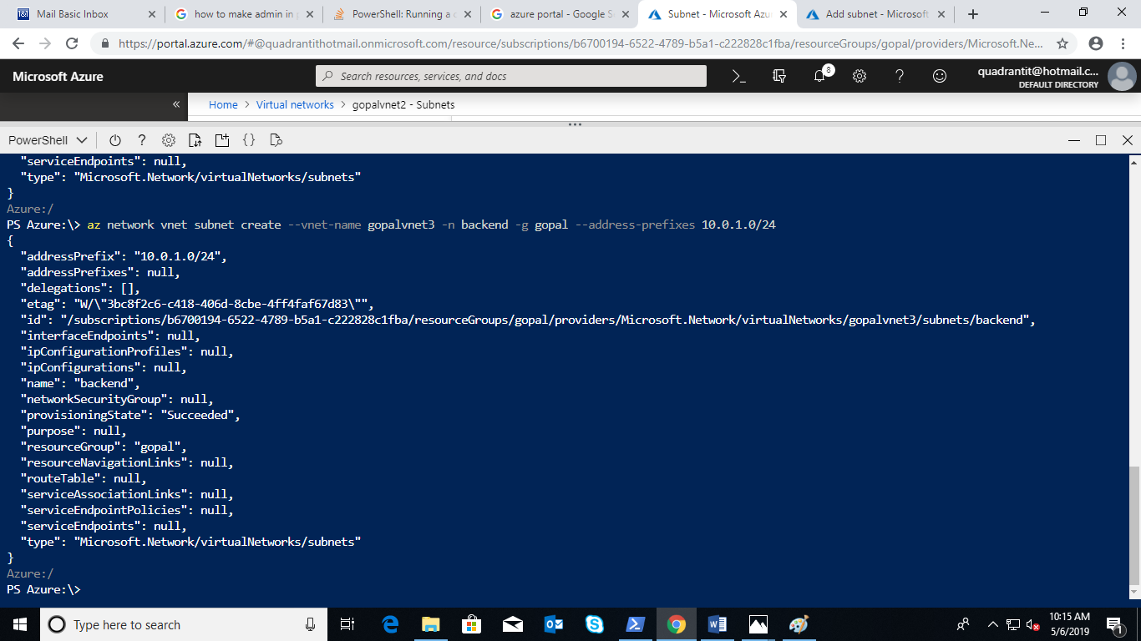

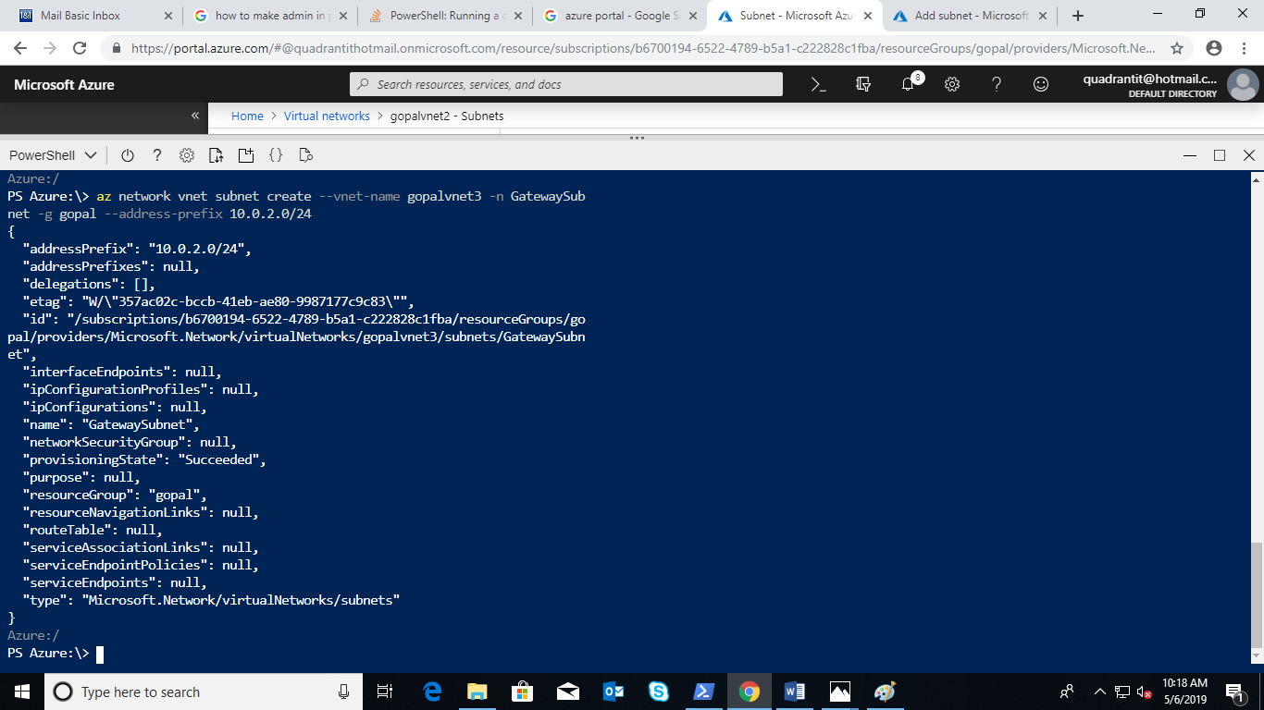

Public ip Request for Vnet1.

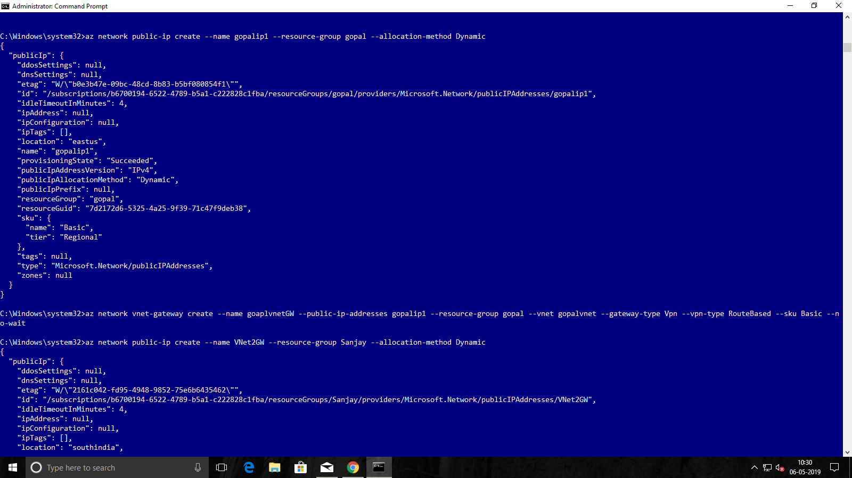

Public IP request for Vnet2.

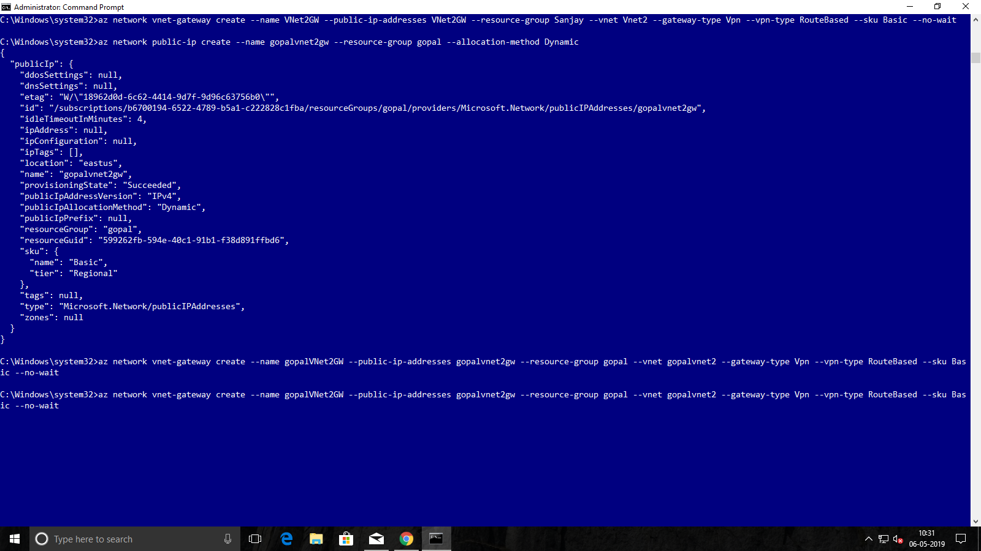

VPN Connection between Vnet1 to Vnet2.

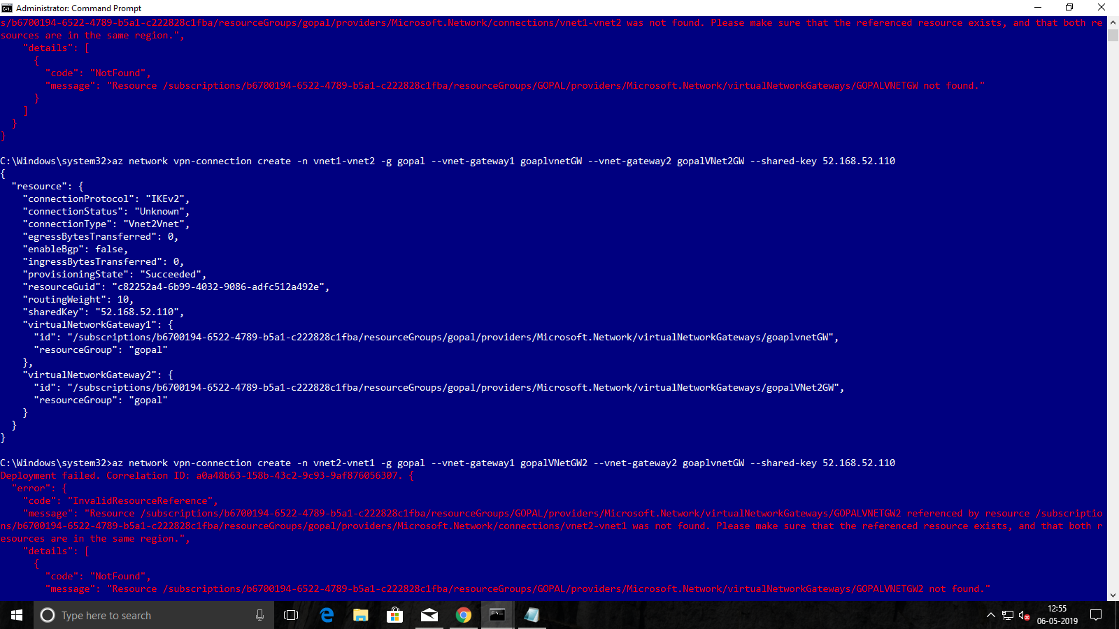

VPN Connection Between Vnet2 to Vnet1.

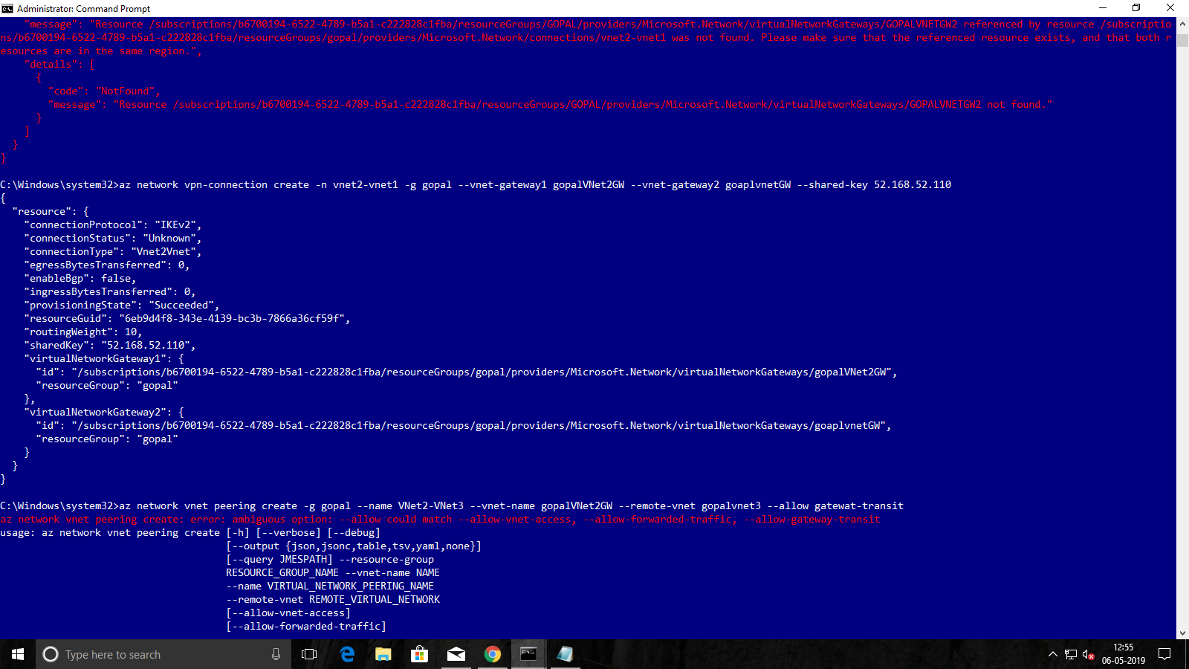

Creation of VPN Gateway for Vnet1.



Create the VPN Peering for Vnet2 and set the Hub .

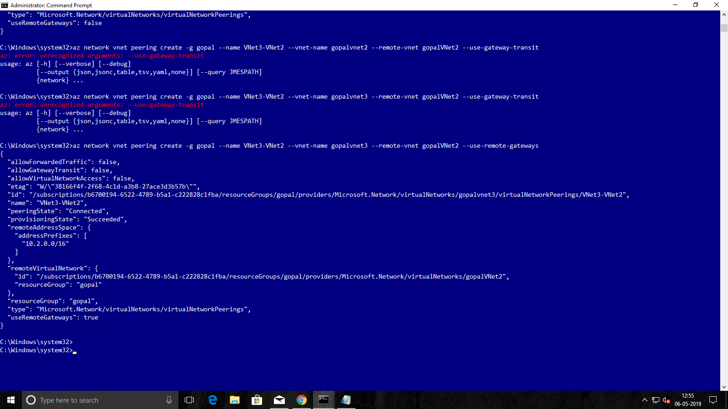

Create the VPN Peering for Vnet3 and set the Spoke .

